UNIVERSITY OF ENERGY AND NATURAL RESOURCES, SUNYANI

SCHOOL OF SCIENCES
DEPARTMENT OF INFORMATION TECHNOLOGY AND DECISION SCIENCES

BY
OWUSU FAUSTINA KYEI UEB3261724
Joel Dick-Sagoe UEB3210112
Appiagyei Yaw Konadu Antwi UEB3245124
Agyemang Akosua Twenboah UEB3293224
Gideon Addy UEB3298024

THIS PROJECT WORK IS SUBMITTED TO THE DEPARTMENT OF INFORMATION TECHNOLOGY AND DECISION SCIENCES, IN PARTIAL FULFILLMENT OF THE REQUIREMENT FOR THE AWARD OF BACHELOR OF SCIENCE IN INFORMATION TECHNOLOGY

DECLARATION
To be eligible for an information technology diploma, Faustina Owusu Kyei, Joel Dick-Sagoe, Appiagyei Yaw Konadu Antwi, Agyemang Akosua Twenboah and Gideon Addy attest that the contribution is our own original work. To the best of our knowledge, unless proper acknowledgment has been made in the text, it does not contain any content that has already been published by another person or content for which the University has approved to award any other degree.

NAME | SIGNATURE | DATE
OWUSU FAUSTINA KYEI | ……………………………. | …………………………
(UEB3261724)
Joel Dick-Sagoe | ………………………….. | …………………………
(UEB3210112)
Appiagyei Yaw Konadu Antwi | ……………………………. | …………………………
(UEB3245124)  Agyemang Akosua Twenboah  (UEB3293224) | …………………………… | …………………………
Gideon Addy | ……………………………. | …………………………..
(UEB3298024)

ACKNOWLEDGEMENT
First and foremost, we bestow all the honor that is rightfully ours upon the one who has supported and assisted us, the one who existed, is existing, and will exist forever, the Alpha and Omega the first and the last. We also value the efforts of all of our lecturers, especially Mr. Joseph Mensah and other Department employees, who have helped and taught us in many ways.
God will continuously assist them and lavishly bless them.
DEDICATION
This project effort is dedicated to the Almighty God, who created the heavens and the earth, is the source of our existence, our support system, and the source of all that has enabled us to succeed in everything. We give Him all praise, honor, and devotion for all eternity, Amen. We are grateful to our family for supporting us during our studies. for their spiritual and monetary assistance. We would also want to express our gratitude to Mr. Joseph Mensah, our capable supervisor, for his unwavering support and invaluable advice during this project.
ABSTRACT
The SafePath Mobile Application is a privacy-aware safety system designed to provide discreet emergency support for individuals at risk of domestic violence. The application is developed to address the limitations of many existing safety solutions, which are often highly visible, easily detectable, or dependent on constant internet connectivity. SafePath integrates key features such as disguised application entry, one-touch emergency alerting, offline access to support resources, location-based assistance, and secure local data storage.
Through an intuitive and stress-tolerant user interface, the system enables users to request help quickly and safely without drawing attention. The application prioritizes user privacy and security by incorporating encryption mechanisms and minimizing sensitive data exposure. Additionally, SafePath is designed to function reliably in low-connectivity environments, ensuring accessibility and effectiveness during emergencies.
The system enhances personal safety, improves access to critical support services, and demonstrates the application of human-centered design and privacy-by-design principles in mobile development. SafePath provides a practical technological solution for vulnerable individuals while contributing to research in safety-focused, discreet digital interventions.

CHAPTER ONE
INTRODUCTION
Domestic violence remains a major global public health and human rights issue, affecting individuals across all societies. The World Health Organization (WHO, 2021) estimates that one in three women worldwide experience physical and/or sexual violence in their lifetime. This highlights the urgent need for accessible and effective support systems for victims.
In the digital era, technology offers new opportunities for assistance but also introduces risks. Abusers increasingly exploit technology for surveillance, control, and intimidation, making victims hesitant to use traditional safety applications. Many existing solutions are easily discoverable through recognizable names, icons, or app histories, which can expose victims to greater danger. Additionally, reliance on continuous internet connectivity limits their effectiveness in low-connectivity environments.
Safety planning for domestic violence intervention emphasizes the need for discreet, secure, and accessible tools. However, few digital solutions adequately address discretion, privacy, and offline functionality particularly in developing contexts such as Ghana, where stigma, economic dependence, and limited awareness of support services remain significant barriers.
Despite Ghana’s Domestic Violence Act (Act 732, 2007), underreporting persists due to fear, stigma, and safety concerns. There is therefore a need for a technology-based intervention that prioritizes privacy, security, and subtle interaction.
This project introduces SafePath, a discreet mobile application disguised as an innocent calculator. The system provides emergency alerting, resource navigation, and secure incident documentation while minimizing visibility and detection risks. By integrating offline functionality, encryption, and stress-tolerant design, SafePath aims to offer victims a safer pathway to assistance.
PROBLEM STATEMENT
Although mobile technology can support victims of domestic violence, many existing safety applications are easily discoverable, making them dangerous for users whose devices are monitored by abusers. Their visible icons, names, and app histories increase the risk of detection and potential harm.
Most current solutions also depend on constant internet connectivity, limiting their usefulness during emergencies when access is restricted or monitored. In addition, these applications often lack integrated features and stress-tolerant design, making them difficult to use under pressure.
Furthermore, many available solutions are not context-specific to Ghana, failing to address local cultural, social, and infrastructural challenges. These limitations highlight the need for a discreet, secure, offline-capable, and user-centered mobile application such as SafePath.
OBJECTIVES
GENERAL OBJECTIVE
The overarching aim of this project is to design, develop, and evaluate a functional prototype of SafePath, a discreet, cross-platform mobile application that provides comprehensive safety features for individuals experiencing domestic violence, while maintaining the appearance of an innocent calculator application to prevent detection and ensure user security.
SPECIFIC OBJECTIVES
- Conduct a requirements analysis to identify key functional and non-functional needs of the application.
- Design a discreet, intuitive, and stress-tolerant UI/UX, ensuring the app functions as a calculator while securely providing safety features.
- Develop a cross-platform SafePath prototype using React Native, including:
A disguised calculator entry with passcode protection
One-touch emergency alerts with location sharing
Offline map of nearby safety resources
Secure encrypted digital journal
- Implement security and privacy mechanisms, including encryption and secure local storage.
- Ensure offline functionality for critical features.
- Perform functional, usability, performance, and security testing.
- Document the design, development, and evaluation process.

RESEARCH QUESTIONS
- What functional and security requirements are necessary for a discreet domestic violence safety app?
- How can the app disguise its true purpose while remaining accessible to legitimate users?
- Which UI/UX design patterns best support rapid use under stress?
- How can emergency alerts and resource features work reliably offline or in low connectivity?
- What encryption and data protection mechanisms are needed to secure sensitive user information?
- How effectively does SafePath meet safety, usability, and functionality requirements?
- What technical and ethical considerations influence deployment in resource-constrained contexts?
SIGNIFICANCE OF THE STUDY
This study makes significant contributions across multiple domains, including academic research, technological innovation, social impact, and practical application. The significance of this work can be understood through several interconnected dimensions. This study also contributes to research in HCI, mobile computing, and privacy-aware design by exploring discreet, safety-critical applications. SafePath introduces innovations in disguised interfaces, offline functionality, and client-side encryption.
The project has potential social impact by improving victim safety, reducing help-seeking barriers, and supporting access to emergency and support resources. It also offers policy, practical, and educational value, with strong relevance to the Ghanaian context.
SCOPE OF THE STUDY
This section delineates the boundaries and limitations of the SafePath project, clarifying what is included within the scope of work and what lies beyond the current project's objectives. Understanding these boundaries is essential for setting appropriate expectations and evaluating the project's success against its defined parameters.
ORGANIZATION OF THE STUDY
This final year project report is systematically organized into five comprehensive chapters, each addressing specific aspects of the SafePath development process and findings. The organization follows a logical progression from problem identification through solution design, implementation, evaluation, and conclusions.

CHAPTER TWO
LITERATURE REVIEW
Literature Review
Many researchers have studied the use of mobile and web applications for communication, emotional support, and counseling. With the development of Artificial Intelligence, many systems can now respond to users automatically and provide suggestions based on user input.
Emotional support applications are designed to help users express their feelings and receive comforting responses. These systems are useful for people who are stressed, anxious, or facing personal problems. However, many of these applications require users to provide personal information such as email, phone number, or real name, which may reduce user trust.
Privacy is one of the most important factors in modern applications. Users want to be sure that their conversations are safe and cannot be accessed by unauthorized persons. Because of this, developers now focus on secure login, encryption, and anonymous communication.
Artificial Intelligence is also used to detect emotions from text messages. Emotion detection allows the system to understand whether the user is happy, sad, angry, or stressed, and respond appropriately.
Despite these improvements, many existing systems still store user data, which may cause privacy risks. This creates the need for a safe and discreet application that protects users while providing emotional support.
RELATED WORKS
Several researchers have developed systems related to emotional support, chatbots, and secure communication platforms.
Some studies focused on AI chatbots that can communicate with users and provide automatic responses. These chatbots are used in customer service, education, and counseling applications. However, many of these chatbots do not provide strong privacy protection.
Other studies focused on secure messaging applications that protect user data using encryption. These applications ensure that messages cannot be read by unauthorized users, but they may not provide emotional support features.
There are also mental health support applications that help users talk about their feelings. These applications are helpful but often require user registration, which reduces anonymity.
From these related works, it can be seen that no single system combines emotional support, privacy protection, and anonymous communication in one application. This project aims to combine all these features into one safe platform.
EXISTING PLATFORMS
There are many existing platforms that allow users to communicate online or receive emotional support. Examples include social media apps, messaging apps, and counseling apps.
Some platforms allow users to chat with friends or counselors, while others use AI to provide automatic responses. These platforms help people communicate easily, but many of them collect user data and store conversations.
Existing platforms usually have the following features:
- User registration
- Messaging system
- Data storage
- Online communication
However, most of these platforms do not provide full privacy or anonymous usage.
Because of this, users may feel uncomfortable sharing personal problems.
IMPORTANCE OF EXISTING PLATFORMS
Existing platforms are important because they show how communication systems work and how users interact with applications.
They help developers understand, how users send messages, how systems store data, how AI responds to users, how security is implemented.
By studying existing platforms, developers can identify their weaknesses and improve them.
Existing platforms also help in designing better systems because they provide ideas for new features and improvements.
This project uses knowledge from existing platforms to create a safer and more private application.
IMPACT OF THE PROPOSED SYSTEM
The proposed safe and discreet application will have a positive impact on users and developers.
1.FOR USERS
The system will provide a safe environment where they can express their feelings without fear. Users will feel more comfortable because the system does not require personal information.
2.FOR DEVELOPERS
The project shows the importance of designing applications with privacy and emotional intelligence.
3.FOR SOCIETY
The system can help reduce stress and emotional problems by giving users a place to talk safely.
The system will also encourage the development of more secure and user-friendly applications in the future.
ADVANTAGES OF SAFE APP APPLICATION
The safe and discreet application has many advantages compared to existing systems.
1.Privacy Protection
The system does not require personal details, which keeps users anonymous.
2.Secure Communication
Messages are protected using security methods to prevent unauthorized access.
3.Emotional Support
The system can detect user emotions and respond in a supportive way.
4.User-Friendly Interface
The application is simple and easy to use.
5.No Data Storage Risk
Sensitive information is not stored permanently.
6.Trust and Comfort
Users feel safe when using the system.
7.Modern Technology
The system uses Artificial Intelligence and security techniques.

CHAPTER THREE
METHODOLOGY AND SYSTEM REQUIREMENT
This chapter offers a thorough explanation of the approach taken to accomplish the project's goals. The Software Development Life Cycle (SDLC) is an organized and methodical process used in the creation of software applications. It consists of a number of stages that direct the creation of software, from conception and concept to development, upkeep, and final software retirement. It illustrates the steps, stages, checkpoints, and progression of the software development life cycle.
This chapter however, highlights the processes and techniques involved in the achievement of objectives.
Adopted Methodology
The Agile Development Methodology is the approach selected for implementing the Safe App, a mobile application designed to support individuals in reporting and responding to domestic abuse situations. Agile is particularly suitable for this type of application because it emphasizes flexibility, rapid delivery, and continuous improvement key factors when developing a sensitive, user-centered safety solution.
The methodology focuses on delivering functional features in short development cycles (sprints), allowing the development team to quickly respond to user feedback, improve usability, and ensure the application remains reliable, secure, and easy to use in urgent situations. Given the critical nature of the Safe App, Agile also supports frequent testing and iteration to enhance performance, privacy, and user safety.
In the context of the Safe App, Agile enables the development of discrete and essential features that can function independently while contributing to the overall goal of protecting users and facilitating quick reporting of abuse.
Sprints: The Agile methodology divides the project into small, manageable units called sprints. Each sprint focuses on delivering a specific set of features based on prioritized user stories, ensuring that functional parts of the application are developed and tested incrementally.
For the Safe App, each sprint can concentrate on implementing critical safety-related functionalities. For example, one sprint may focus on developing the emergency reporting feature, allowing users to quickly report abuse incidents. Another sprint may focus on the emergency alert system, enabling users to send their location and distress signals to trusted contacts. Additional sprints could address features such as the discreet/hidden mode, access to support resources, and secure data handling.
Testing and Feedback:
The Agile methodology places strong emphasis on continuous testing and user feedback to ensure the application effectively meets the needs of its users. This is especially important for the Safe App, where reliability, usability, and security are critical.
At the end of each sprint, the development team conducts testing on the features that have been implemented, such as the emergency reporting system, alert notifications, or discreet interface. User testing may involve selected participants or stakeholders who can provide feedback on ease of use, response time, and overall functionality.
The feedback gathered is then used to guide improvements in the next sprint. This iterative process ensures that the Safe App is continuously refined, addressing user concerns, enhancing safety features, and adapting to real-world needs. As a result, the application becomes more effective, user-friendly, and trustworthy over time.
This approach ensures that essential features are delivered early, continuously improved, and remain reliable, secure, and easy to use in sensitive and urgent situations.
Continuous Delivery:
A key principle of the Agile methodology is the regular and continuous delivery of functional software. For the Safe App, this means that the development team consistently integrates new features and improvements into the application in small, manageable updates.
Through continuous delivery, essential functionalities such as emergency reporting, alert systems, and security enhancements can be released frequently to users. This ensures that the app remains up to date, reliable, and responsive to users’ needs, especially in critical situations.
By adopting this approach, the Safe App can quickly adapt to feedback, address emerging safety concerns, and improve overall performance. This guarantees that users always have access to the most effective and secure version of the application.

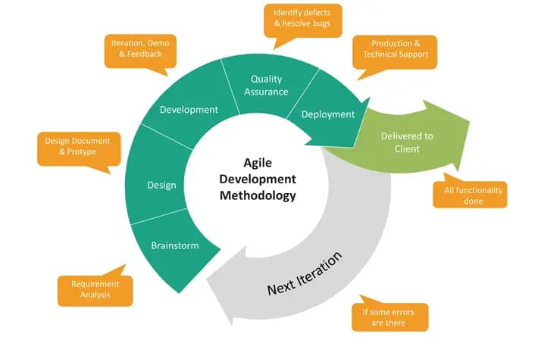 Phases of Agile Development Methodology

Objective Determination and Identification of Alternative Solutions:
At the beginning of each stage of development, requirements are gathered from potential users, stakeholders, and relevant support organizations. These requirements are carefully analyzed to clearly define and refine the objectives of the Safe App, ensuring that the application effectively addresses the needs of individuals facing domestic abuse situations.
During this process, different possible solutions are also explored and evaluated. For example, alternative approaches to reporting incidents, sending emergency alerts, or maintaining user privacy are considered. The most suitable solutions are then selected based on factors such as usability, security, reliability, and the ability to function effectively in urgent and sensitive situations.
This approach ensures that the Safe App is designed with clear goals and incorporates the most effective features to support user safety and accessibility.
Identification and Resolution of Risks:
In the second phase of development, each proposed solution is carefully evaluated to determine the most suitable option for the Safe App. This involves analyzing the potential risks associated with each feature or approach, particularly those related to user safety, data privacy, and system reliability.
Possible risks such as unauthorized access to sensitive information, failure of emergency alerts, or usability challenges in high-stress situations are identified and assessed. Appropriate strategies are then developed to minimize or eliminate these risks, such as implementing strong security measures, ensuring reliable communication systems, and designing a simple, intuitive user interface.
Based on this evaluation, the most effective and secure course of action is selected. This process ensures that the Safe App provides a safe, dependable, and user-friendly experience for individuals in critical situations.
Development of the Next Version of the Product:
In this phase, the next version of the Safe App is designed, developed, and tested. The features identified in the earlier stages, such as emergency reporting, alert systems, and privacy controls are implemented as part of the new version of the application.
Once developed, these features are thoroughly tested to ensure they function correctly, are reliable, and meet the intended objectives. Special attention is given to usability, speed, and security, considering the sensitive and urgent nature of the app.
This iterative process ensures that each new version of the Safe App improves on the previous one, delivering enhanced functionality, better performance, and a safer user experience.
Review and Planning for the Next Phase:
At this stage, the development team reviews the current version of the Safe App to evaluate its functionality, usability, and security. Feedback from testing and user input is carefully analyzed to identify areas for improvement and ensure that all objectives are being met.
Based on this evaluation, the next phase of development is planned. Tasks and priorities are drafted, improvements are outlined, and the next set of features or enhancements is scheduled for implementation. This ensures a structured, iterative approach, allowing the Safe App to evolve continuously while remaining reliable, user-friendly, and secure.

Data flow Diagram
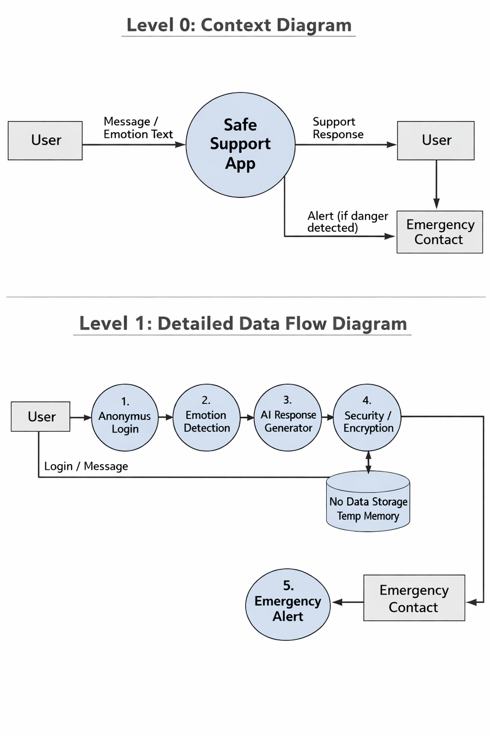
System Architecture:
System architecture provides an abstract or high-level representation of a system, often referred to as a conceptual model. It offers a framework for understanding and describing the system’s key components, their relationships, and overall behavior.
The conceptual model for the Safe App illustrates the main elements of the application and how they interact to ensure user safety and efficient reporting of abuse. The app is accessible to users who need to report incidents, send emergency alerts, or access support resources. It also includes administrative components that allow support personnel to securely manage and respond to reports, monitor system activity, and maintain the integrity and security of user data.
This architecture ensures a clear understanding of the system’s structure, guiding the development of a secure, reliable, and user-friendly application.
System Architecture for Safe App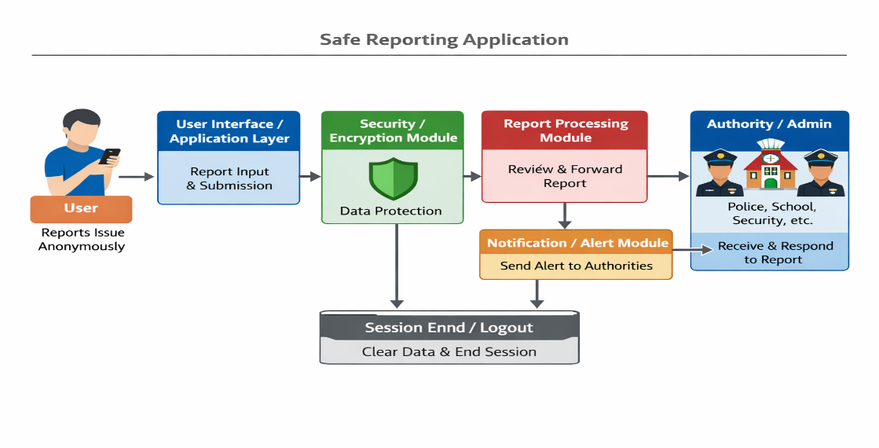
The system architecture of the Safe Reporting Application shows how different parts of the system work together to allow users to report problems safely and anonymously. The system is designed to protect user identity and send reports to the appropriate authorities for action.
The architecture consists of several components which interact to ensure privacy, security, and proper handling of reports.
1. User
The user is the person who uses the application through a mobile phone or computer.
The user can send a report about a problem such as harassment, danger, crime, or emergency.
The system allows the user to report anonymously without providing personal details.
Functions of the user include open the app, send report, attach message or description, submit complaint, end session
2. User Interface / Application Layer
This is the main part of the system that connects the user to the application.
It receives the report from the user and sends it to the system for processing.
The application layer controls how information moves inside the system.
Functions:
- Receive user input
- Send report to security module
- Display confirmation message
- Manage user session
3. Security / Encryption Module
This module protects the user’s information.
It ensures that the report is secure and cannot be seen by unauthorized persons.
This module is very important because the system is designed to be discreet and safe.
Functions:
- Encrypt report
- Protect user identity
- Prevent unauthorized access
- Maintain privacy
4. Temporary Memory or Secure Storage
The system stores the report temporarily or in a secure database so that authorities can access it. Sensitive information is protected and only authorized people can view it.
Functions:
- Store report securely
- Allow authorized access
- Prevent data leakage
- Delete unnecessary data
5. Report Processing Module
This module checks the report sent by the user and forwards it to the correct authority.
Functions:
- Receive report
- Verify report
- Forward to the authority
- Record action status
6. Authority or Admin
The authority is the person or organization responsible for taking action.
This can be police, school authority, counselor, security agency, government office
Functions:
- Receive report
- Read report
- Take action
- Respond to case
7. Notification
This module sends alerts to the authority when a report is submitted. It ensures that the report is not ignored. It may also perform functions like, send notification, alert authority, confirm delivery
8. Logout
After the user finishes reporting, the session ends and the system clears temporary data.
This helps to keep the app safe.
Functions:
- Clear temporary data
- Protect user end session
- privacy
Functional Requirements
- User report submission
- Anonymous reporting
- Secure data encryption
- Report storage
- Report processing
- Authority or admin access
- Notification or alert system
- Session management
- Data protection
- Logout or exit function

Non-Functional Requirements
- Security
- Privacy protection
- Reliability
- Availability
- Usability
- Performance
- Scalability
- Maintainability
- Compatibility
- Data integrity
- Response time
- Confidentiality
- Error handling
- Backup and recovery
- System stability
Use Case Diagram
The main goal of use case diagrams is to illustrate the many use cases that is, certain interactions or behaviors that users or other external entities have with the system. They offer a high-level overview of the system's behavior and assist stakeholders in comprehending the functionality of the system from the viewpoint of a user.
An example of a behavioral diagram in the Unified Modeling Language (UML) is one that shows how users or other systems interact with a system. It gives a system's or software application's functional needs and usage scenarios a visual representation. A use case diagram's main elements are actors, use cases, and communication channels.
The users, people, or external systems that communicate with the system under modeling are represented as actors. They start conversations with the system or take part in them. They interact with the system to carry out certain actions or objectives.
System Actors
System actors refer to the entities or components that interact with the system being developed. These actors can be human users, external systems, hardware devices, or any other entity that plays a role in the system's functionality.
Go to hotel websitez
1. User
The user is the person who uses the application to report a problem.
The user interacts directly with the Safe App System.
The user can submit report, check report status, receive confirmation, logout or exit. The system allows the user to report anonymously to ensure safety.
2. Submit Report
This use case allows the user to send a complaint or report through the application.
The report may contain a description of the problem.
The system will:
- Accept the report
- Protect the user identity
- Send the report for processing
3. Check Report Status
This use case allows the user to see if action has been taken on the report.
The system will:
- Find the report
- Show the current status
- Display update to the user
4. Receive Confirmation
After submitting a report, the system sends confirmation to the user to show that the report was received successfully. This helps the user know that the message has been delivered.
5. Logout or Exit
This use case allows the user to leave the application safely.
The system will:
- End session
- Clear temporary data
- Protect user privacy
6. Store Report Securely
This use case ensures that all reports are saved in a secure storage.
It will perform functions like;
- Save report.
- Protect data.
- Allow only authorized access.
- This prevents unauthorized people from seeing the report.
7. Notify Authority
After the report is stored, the system sends a notification to the authority.
The notification system will perform functions like;
- Send alert
- Inform authority
- Confirm delivery
8. Authority Admin
The authority is responsible for handling the report.
The authority can:
- Review reports
- Take action
- Update report status
- Authorities may include:
- Police
- School authority
- Security service
- Organization management
9. Review Reports
This use case allows the authority to read the report sent by the user.
The authority can
- Open report
- Check details
- Decide action
10. Take Action
After reviewing the report, the authority takes the necessary action.
Action may include, investigation, warning, help request, security response.
11. Notification System
This part of the system sends alerts when a new report is submitted.
It ensures that reports are not ignored.
It will perform functions like;
- Send message
- Notify authority
- Confirm alert
12. Secure Storage
Secure storage keeps reports safe in the database.
It ensures:
- Data protection
- Authorized access only
- No data leakage

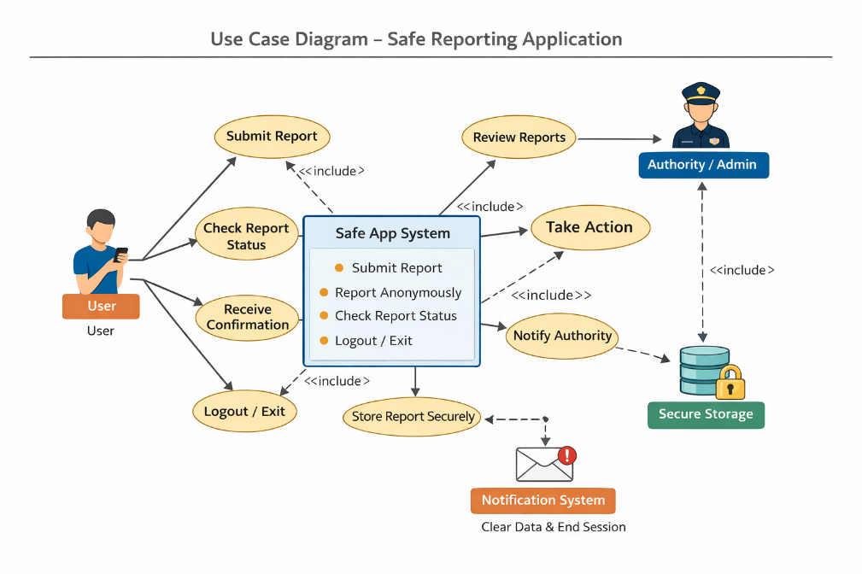

Computing Environment and Operating System
The development laptop, an Acer Aspire 5 A515-52G-701C, has the following specifications:
1. Processor: The laptop boasts an Intel Core i7 processor, giving fast performance and efficient multitasking capabilities.
2. Memory: With 8GB of DDR4 RAM, it can handle resource-intensive tasks and operate smoothly.
3. Storage: With a 512GB solid-state drive (SSD) on the laptop, there is more than enough room for papers, multimedia files, and project files.
4. Graphics: It has an NVIDIA GeForce MX150 graphics card installed, which allows for fluid graphics processing and rendering for graphically demanding applications.
5. Display: The laptop's 15.6-inch Full HD display, with its vivid colors and crisp images, makes using the e-learning platform more enjoyable for the user.
6. Operating System: The laptop's Windows operating system offers a recognizable and easy-to-use environment for project execution and software development. I'm using Windows 11 right now.
Wi-Fi, Bluetooth, USB ports, and an HDMI port are just a few of the communication choices it has. These enable smooth connectivity with external devices and networks.
The Acer Aspire 5 A515-52G-701C laptop's system requirements offer a strong basis for developing and managing the e-learning platform, guaranteeing streamlined operation and effective growth.
Technologies Used in Programming
The development of the SafePath application utilized modern technologies to ensure efficiency and a smooth user experience. The front end was built using React, a powerful JavaScript library that enables the creation of dynamic, responsive, and interactive user interfaces.
For the back end, Node.js was used to handle server-side operations, including managing requests, processing data, and enabling communication between different parts of the system. Its efficiency and scalability make it well-suited for building fast and reliable applications.
Together, React and Node.js provide a robust and efficient environment for developing a modern and high-performing hotel management platform.

